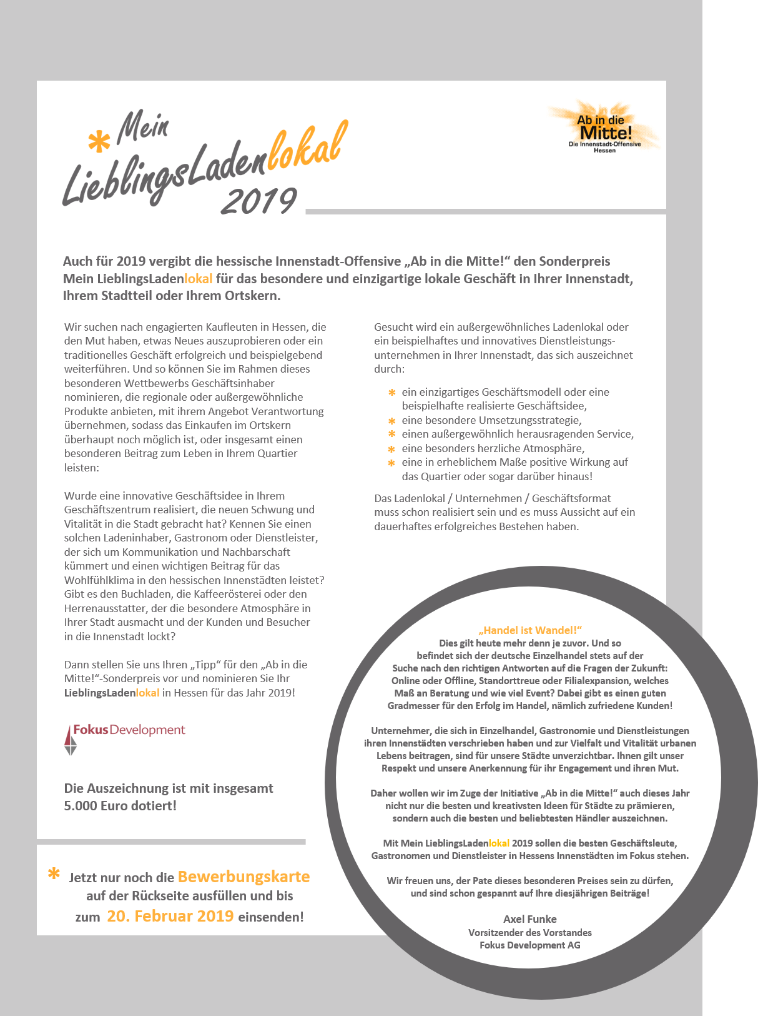

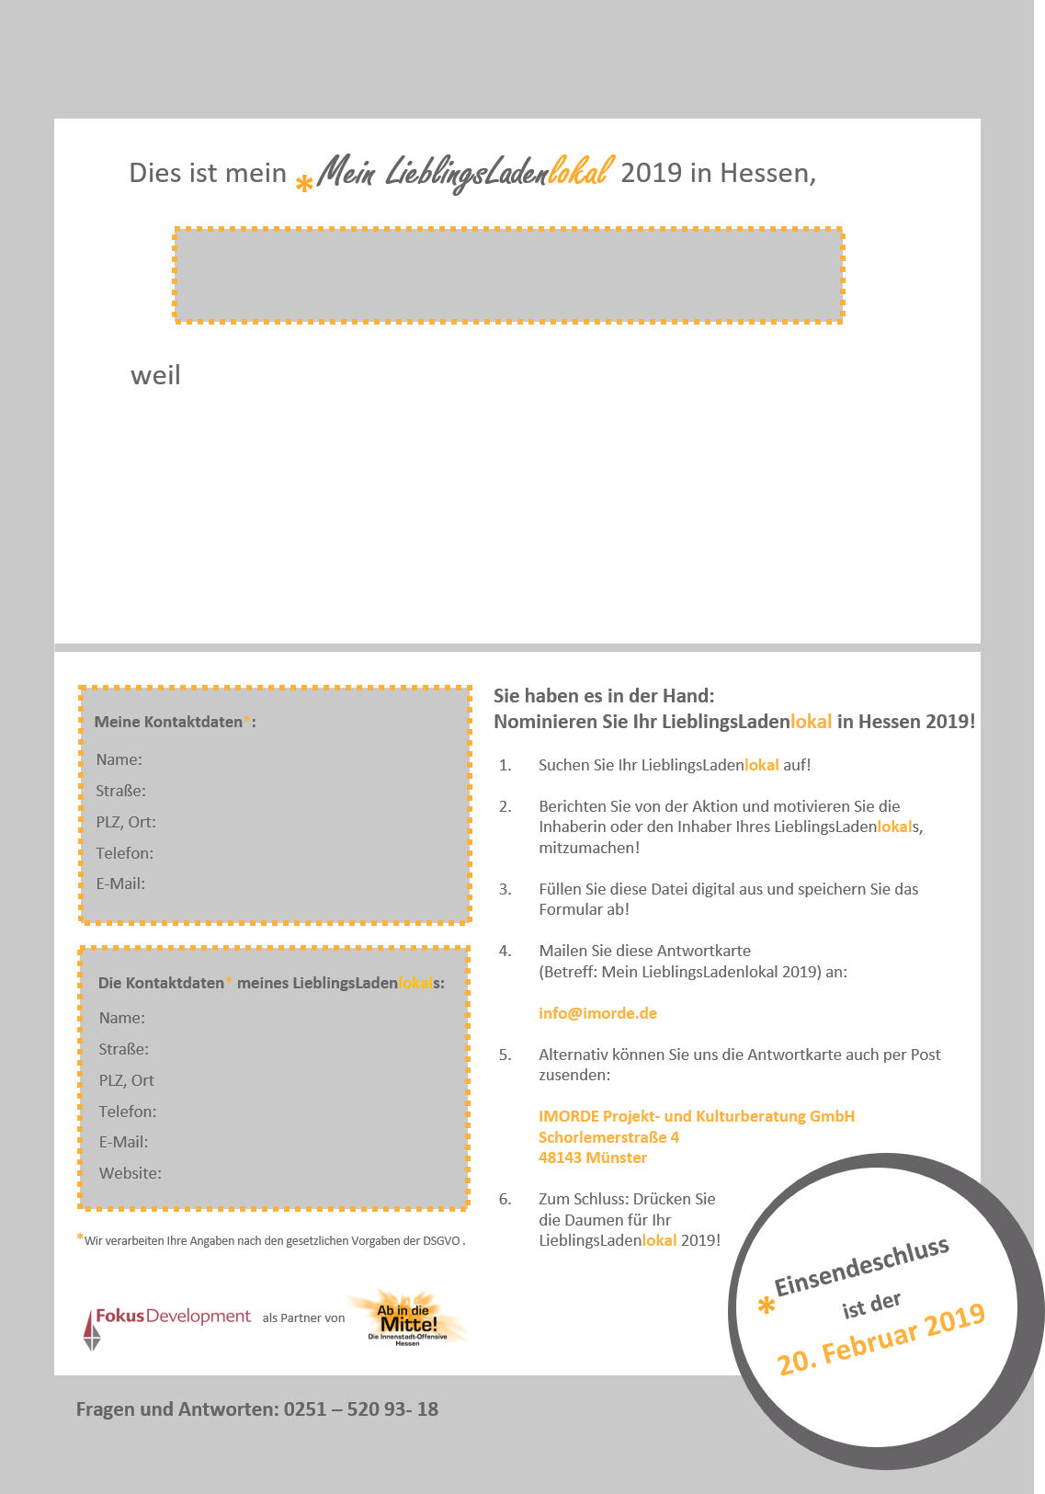

|  |
| --- |
| *Klicken oder tippen Sie hier (…), um Ihren Text einzufügen.* |

|  |  |  |  |  |  |  |  |  |  |  |  |  |
| --- | --- | --- | --- | --- | --- | --- | --- | --- | --- | --- | --- | --- |
| |  | | --- | | *(…)* |  |  | | --- | | *(…)* | | *(…)* | | *(…)* | | *(…)* | | *(…)* |      |  | | --- | | *(…)* | | *(…)* | | *(…)* | | *(…)* | | *(…)* | | *(…)* | |
|  |