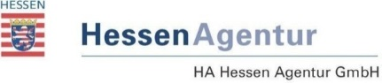
*** Buchungsbestätigung ***
HA Hessen Agentur GmbH
Tourismus- und Kongressmarketing
E-Mail an kommunikation@hessen-tourismus.de

Online-Aktion „Badespaß in Hessen 2018“
auf www.hessen-tourismus.de und Facebook

Anmeldeschluss: 27. April 2018

☒ Buchung eines Eintrags auf www.hessen-tourismus.de.
Beginn 7. Mai bis Ende der wetterabhängigen Badesaison 2018

- Kosten: 140,- Euro zzgl. ges. MwSt.
- Zulieferung:
  - Buchungsbestätigung
  - beschreibender Text von maximal 1200 Zeichen (inkl. Leerzeichen) + Überschrift mit maximal 55 Zeichen (siehe vorgegebener Text)
  - Bildmaterial mit den folgenden Spezifikationen:
3-5 Bilder (Querformat 1920px x 1100px oder größer) mit Bildunterschrift + Bildnutzungsvereinbarung!
  - wenn vorhanden Videomaterial (Bildnutzungsvereinbarung!)

Institution/Firma: ........................................................................................................
Ansprechpartner: ........................................................................................................
Anschrift: ........................................................................................................
…………………………………………………………………………...
Telefon, Fax: ........................................................................................................
E-Mail: ........................................................................................................

Datum, Stempel, (digitale) Unterschrift

